**16-BIT MULTIPLICATION**  
  
  
**EXP NO: 7**  
  
**AIM:**

To write an assembly language program to  
implement 16-bit multiplication using 8085 processor.

**ALGORITHM:**  
  
  
1)Load the first data in HL pair.  
2)Move content of HL pair to stack pointer.  
3)Load the second data in HL pair and move it to DE.  
4)Make H register as 00H and L register as 00H.  
5)ADD HL pair and stack pointer.  
6)Check for carry if carry increment it by 1 else move to next step.  
7)Then move E to A and perform OR operation with accumulator and register D.  
8)The value of operation is zero, then store the value else go to step 3.  
  
**PROGRAM:**

LHLD 2050

SPHL

LHLD 2052

XCHG

LXI H,0000H

LXI B,0000H

AGAIN: DAD SP

JNC START

INX B

START: DCX D

MOV A,E

ORA D

JNZ AGAIN

SHLD 2054

MOV L,C

MOV H,B

SHLD 2055

HLT

**INPUT:**

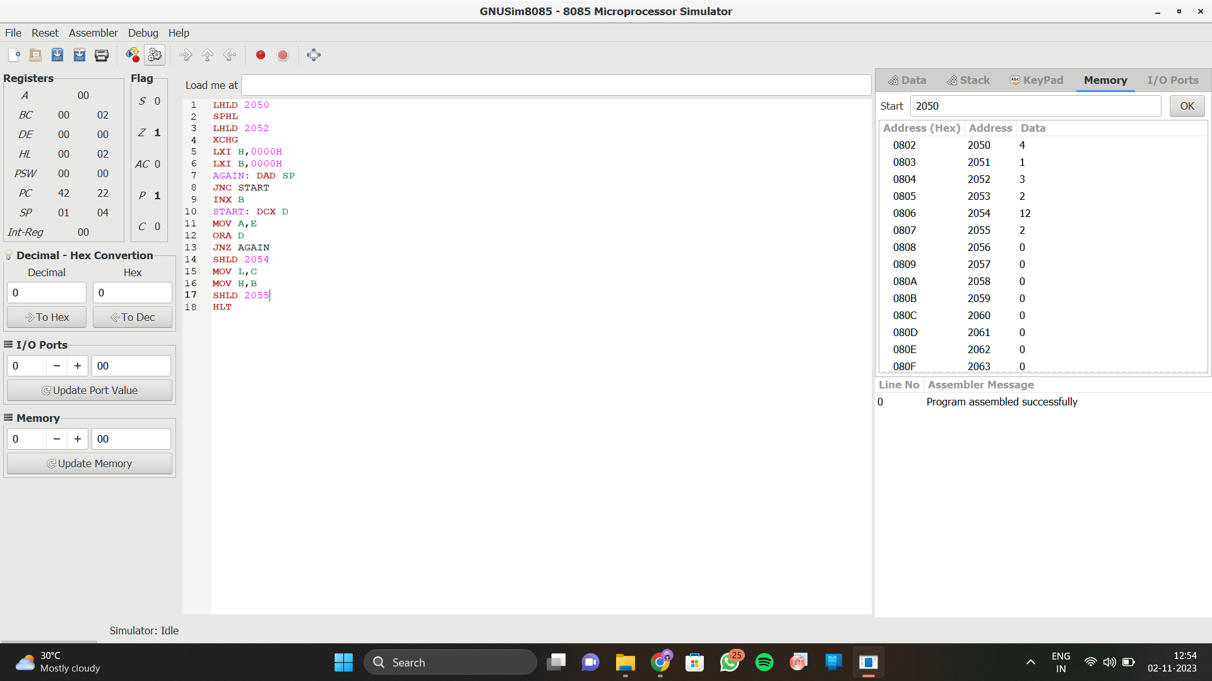

**OUTPUT:**

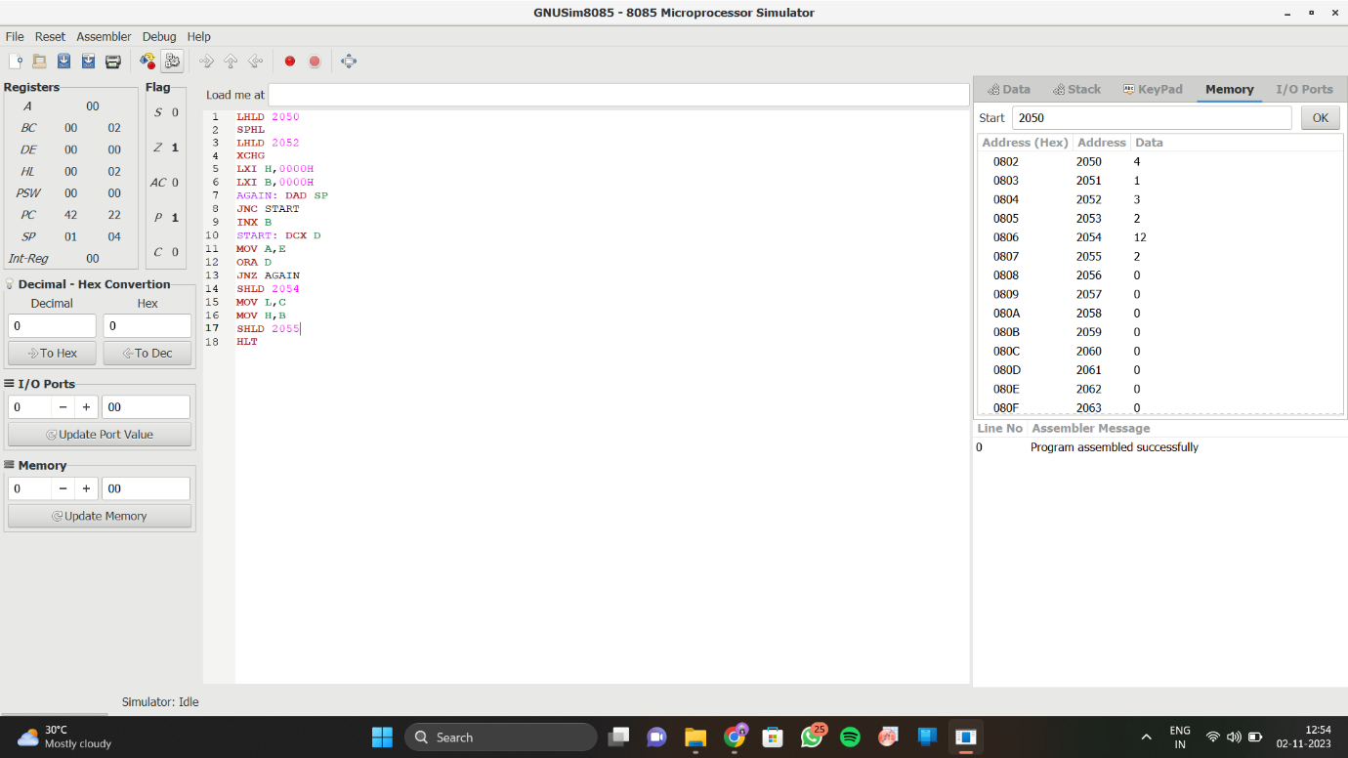  
  
  
  
  
  
**RESULT:**

Thus the program was executed successfully using 8085 processor simulator.